Hôm nay finish TT-seq1, xử lý những dataset còn lại, cụ thể:
- Download paired-end cho TTseq5 với –split-3.
- TTseq3 với –split-3 hoặc --split-files đều ko trả về paired-end mà chỉ trả về 1 file. Cat nội dung thì cũng ko chứa paired-end. Nếu dùng --split-files -M 0 thì được

What is the Difference Between RNA Splicing and Alternative Splicing?

The main difference between RNA splicing and alternative splicing is that the RNA splicing is the process of splicing the exons of the primary transcript of mRNA whereas the alternative splicing is the process of producing differential combinations of exons of the same gene. Furthermore, RNA splicing is responsible for the production of a mRNA molecule that can be translated into a protein while alternative splicing is responsible for the production of a range of proteins from the same primary transcript.
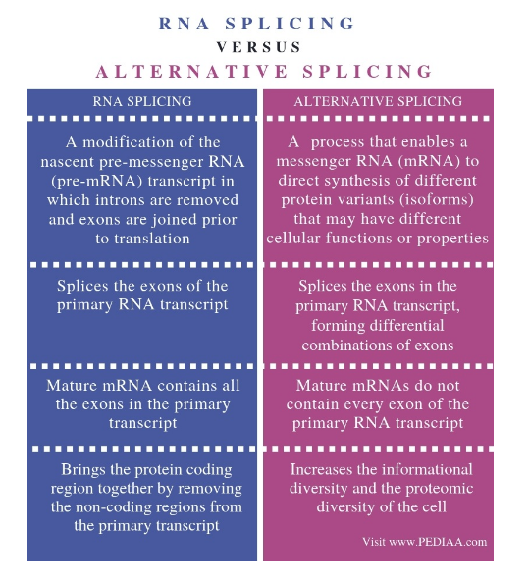

STAR parameters use by authors (TT-seq1):

Splice Junction: in the splicing of RNA, the site of a former intron in a mature mRNA

overhang is the length of the piece of the read which is spliced apart

--alignSJDBoverhangMin (and similarly --alignSJoverhangMin for unannotated junctions) prohibits alignments with very small spilce overhangs. This is done for each read independently of all other reads.
The alignments with smaller overhangs never make it to the Aligned.out.sam file.

On the other hand, --outSJfilterOverhangMin (and other outSJ* parameters) controls the output of "collapsed" junctions into the SJ.out.tab.
"Collapsing" means that the information is collected from spliced reads that support a particular junction (intron) in the genome.
While there are many millions of spliced reads, there will be only a few hundred thousands of collapsed junctions (i.e. the number of lines in SJ.out.tab).
The last column of the SJ.out.tab file reports the maximum overhang over all the reads that support each junction.
The --outSJfilterOverhangMin parameter prohibits outputting into SJ.out.tab those junctions which for all supporting reads have overhangs smaller than 30/12/12/12 (depending on the intron motif).
This (and other parameters like --outSJfilterCountUniqueMin, --outSJfilterCountTotalMin, --outSJfilterDistToOtherSJmin, --outSJfilterIntronMaxVsReadN) allows to create a highly confident set of detected splice junctions in the SJ.out.tab.
Note that if you are using annotations (sjdb), only unannotated junctions are affected by these filtering parameters, all annotated junctions are output into SJ.out.tab without filtering.

By default --outSJfilter* parameters do not affect alignments in the Aligned.out.sam file.
However, if you use --outFilterType BySJout option, splicing of alignments in the Aligned.out.sam will only be allowed across the junctions which pass the filtering into SJ.out.tab.
This option makes Aligment.out.sam file consistent with SJ.out.tab file.

It probably sounds a bit cumbersome, but the logic is simple, I believe:
First, we filter all the alignments with very short ovehangs, --alignSJDBoverhangMin 3 --alignSJoverhangMin 5.
Next, we create a confident set of junctions by requiring that at least one supporting read has a large enough overhang >= --outSJfilterOverhangMin 30 12 12 12 (i.e. 12 for unannotated canonical motifs, or 30 for non-canonical).
Finally, with --outFilterType BySJout we prohibit any alignments across the junctions that did not make into the confident set.

As an example, imagine that you have an unannotated GT/AG that is crossed by three uniquely mapped spliced reads, with overhangs 6,9 and 12.
This intron will make into the SJ.out.tab file with "unique read count" (col 7) of 3, and the max overhang (col 9) of 15. Also, all three splices will be reported in Aligned.out.sam file.
If the three overhangs were 6,9 and 11, the intron would not make it into the SJ.out.tab - but by default the spliced alignments would be reported in the Aligned.out.sam.However,
if you used --outFilterType BySJout, those splices would not be allowed in the Aligned.out.sam, and their alignments would most likely contain soft clipping (S) instead of splices.

-outFilterMultimapNmax 1 : max number of multiple alignments allowed for a read: if exceeded, the read is considered unmapped → unique mapped read

-alignSJoverhangMin 8: minimum overhang for unannotated junctions (8= default)

-alignSJDBoverhangMin 1 : minimum overhang for annotated junctions (1= default)

-outFilterMismatchNmax 999 : maximum number of mismatches per pair, large number switches off this filter

-outFilterMismatchNoverLmax 0.02 : default: 0.3 real: alignment will be output only if its ratio of mismatches to *mapped* length is less than or equal to this value

-alignIntronMin 20 : minimum intron length

-alignIntronMax 1000000 : maximum intron length

-alignMatesGapMax 1000000: maximum genomic distance between mates

